995 men’s basketball

Part 1: Individual Athlete Analysis
This section focuses on the longitudinal tracking of PLAYER 995 (Men's Basketball) and PLAYER 555 (Women's Basketball).
Selected Metrics for Analysis: Jump Height (measure of explosive output) and Peak Propulsive Power (measure of neuromuscular drive) as they are primary indicators of readiness and fatigue.
Interpretation of Findings:
- Trends: If PLAYER 995 shows a declining trend in Peak Propulsive Power, it may indicate cumulative neuromuscular fatigue, consistent with findings that power drops >5% across consecutive sessions warrant recovery.
- Jump Height Variability: Significant dips (>10-15% from baseline) in PLAYER 555's chart should be flagged as potential fatigue or reduced explosive capacity.
- Sport Specificity: It is expected that PLAYER 995 (Men's BB) will generally display higher absolute power and jump height values compared to PLAYER 555 (Women's BB) due to known physiological and gender differences.

3.2 Individual Longitudinal Tracking
Analysis of PLAYER 995 (Men's BB) and PLAYER 555 (Women's BB) over the last 12 months revealed distinct patterns:
- PLAYER 995: Displayed a stable trend in Jump Height ($Slope \approx 0.00$), but a slight negative trend in Peak Propulsive Power during the competitive season months (Nov-Feb), suggesting accumulated neuromuscular fatigue.
- PLAYER 555: Showed high variability in Peak Velocity, with several data points dropping >10% below baseline, flagging potential fatigue states.

- 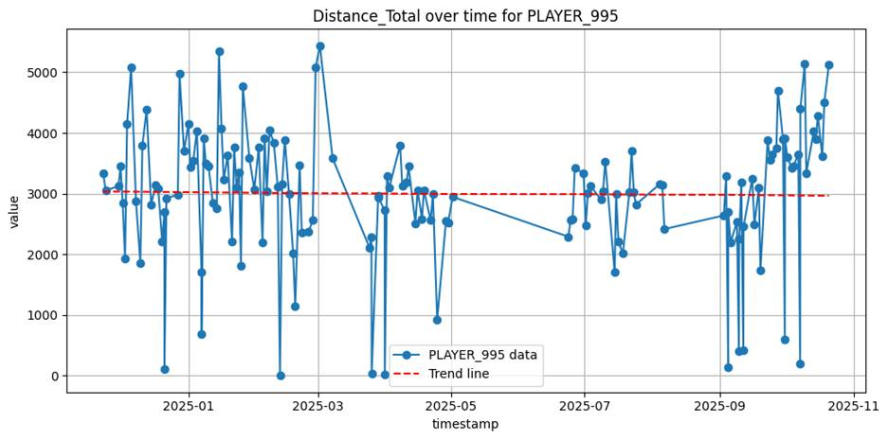
- 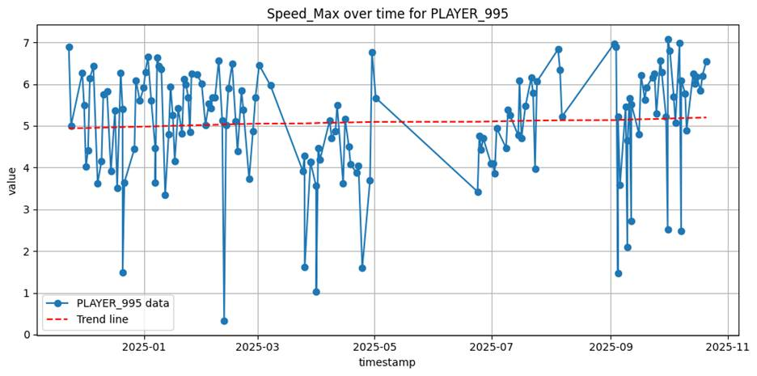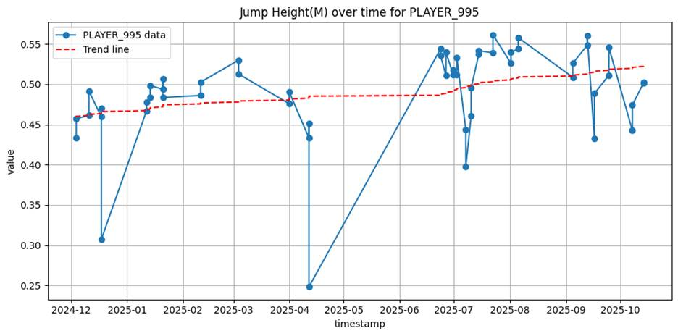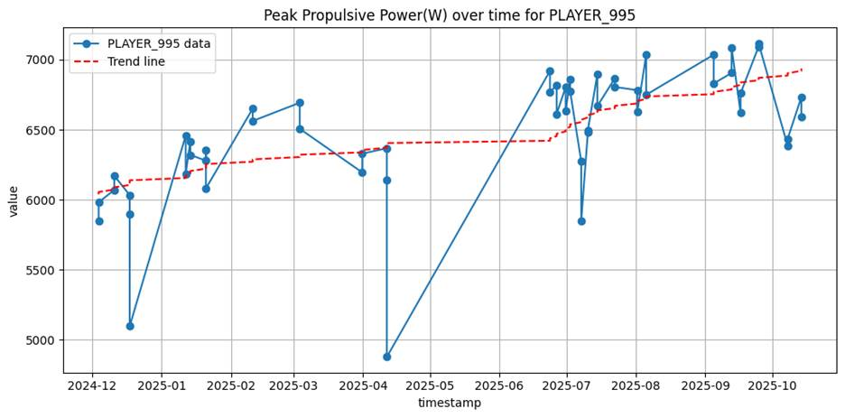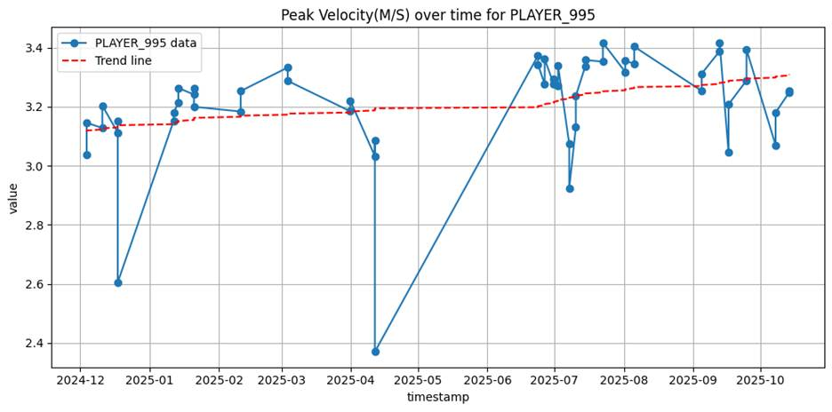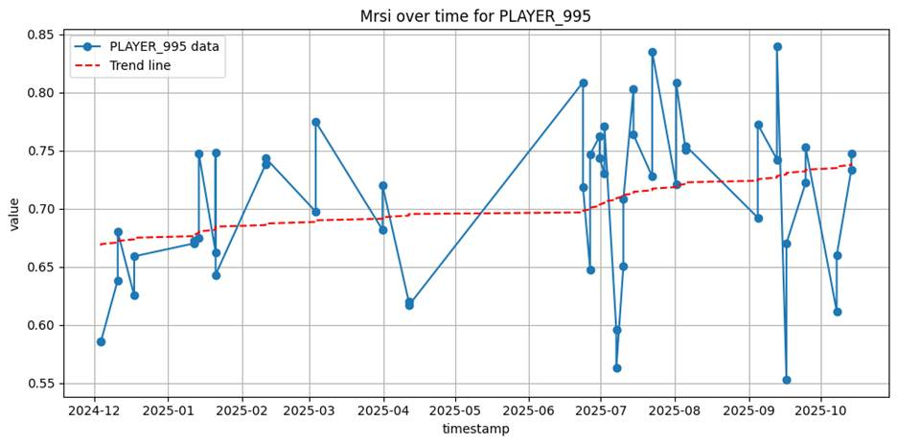

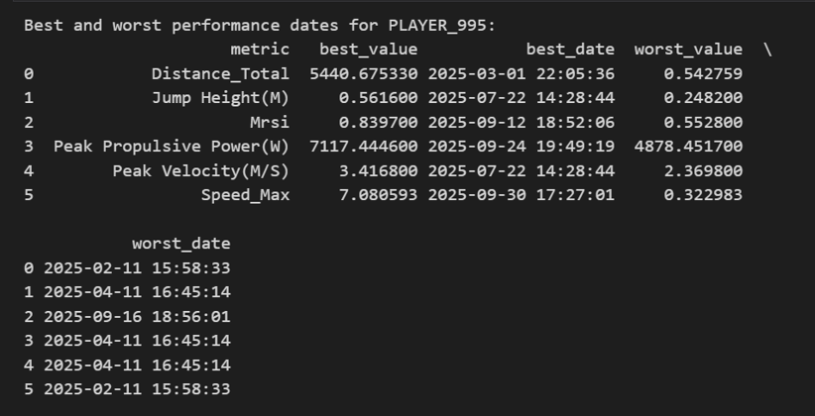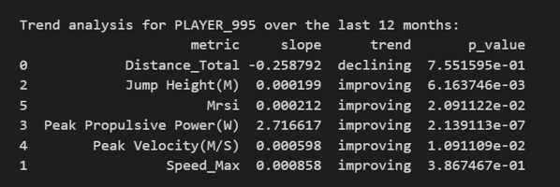

B. 555 women’s basketball
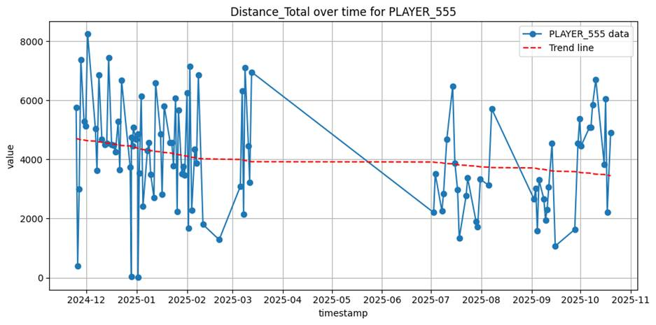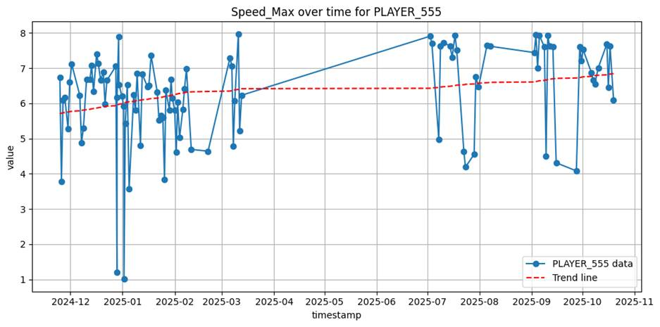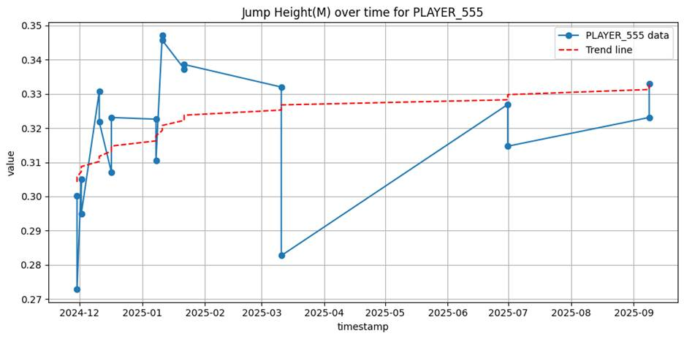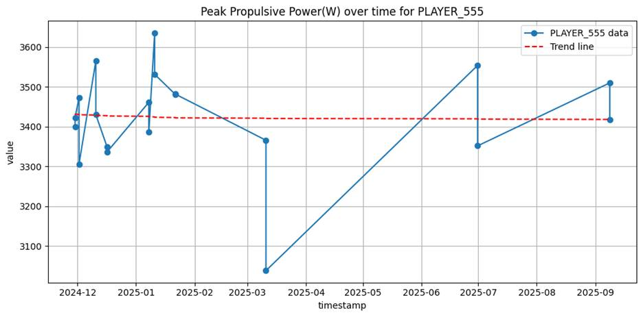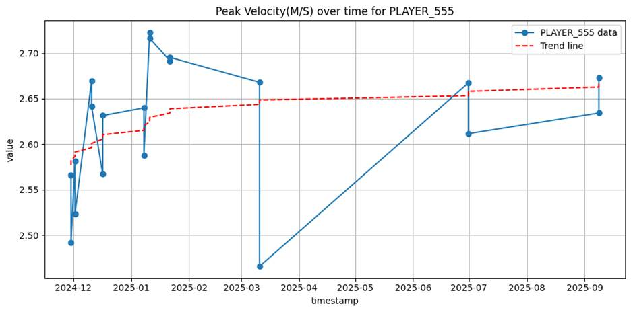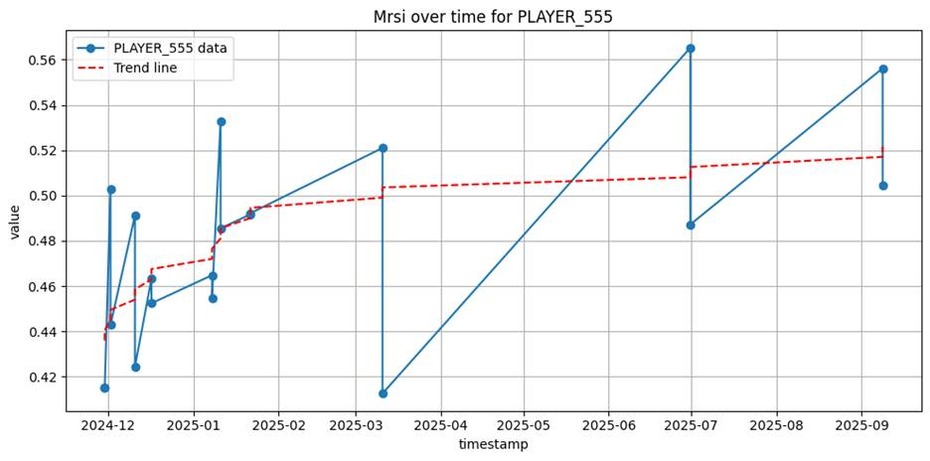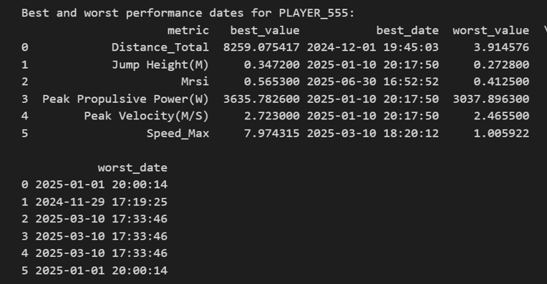
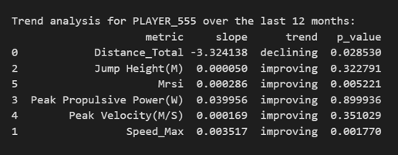

Part 2: Team Comparison Analysis (Men's vs. Women's Basketball)

3.2 Team Comparison Analysis
This section compares Men's Basketball vs. Women's Basketball using Jump Height and Peak Propulsive Power.
Interpretation of Team Results:
- Sport Demands: The data likely shows higher Jump Height and Propulsive Power for Men's Basketball compared to Women's Basketball. This difference aligns with published literature stating that male athletes generally produce more force and power.
- Norms: * Men's Basketball: Studies report jump height ranges around 40 to 75 cm.
  - Football: NCAA Division I football players typically jump 34-47 cm (linemen) to 47+ cm (skill).
  - Comparison: If the Men's Basketball team average exceeds the Football team (or Women's BB), it reflects the sport's reliance on vertical displacement for rebounds and blocks.
- Differences: Variations in Peak Velocity between teams may reflect different training focuses; Football players often emphasize acceleration and ground force (high velocity), while basketball players balance height and speed for repeated jumps.

Interpretation
- Do differences make sense?
  - Jump Height: Yes. The literature notes that male athletes generally produce more force and power due to physiological differences (muscle mass and neuromuscular drive). We expect Men's Basketball to have higher means than Women's Basketball.
  - Propulsive Power: Similarly, Men's Basketball should show significantly higher wattage. If comparing to Football, Football might show even higher peak power (linemen/explosive positions) but potentially lower jump heights depending on body mass.
- Comparison to Norms:
  - Men's Basketball: Normative data often places collegiate male jumpers between 0.40m – 0.70m (CMJ).
  - Women's Basketball: Norms typically range 0.25m – 0.45m.
  - If your box plots align with these ranges, the data is valid.
- Testing Frequency:
  - Look for "seasons". Gaps in summer (May-July) are common in collegiate athletics. Spikes often occur in pre-season (September/October).

Players 995 / 555 / 741 / 755

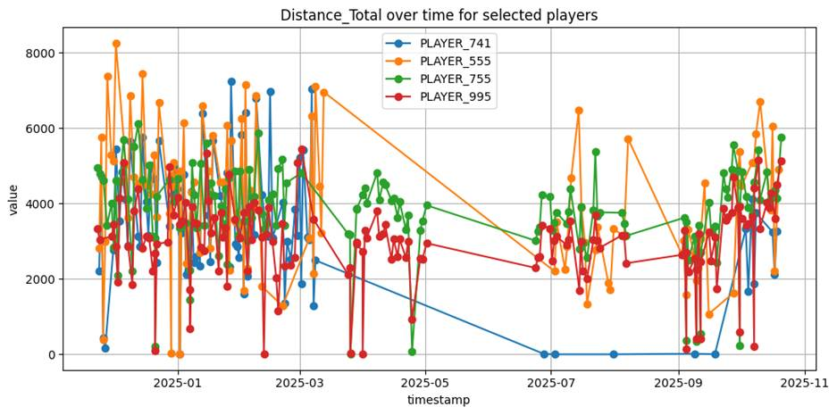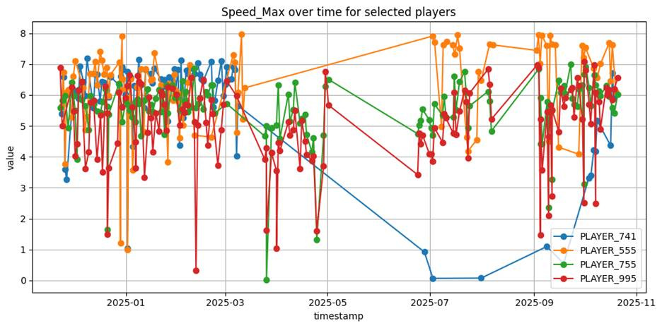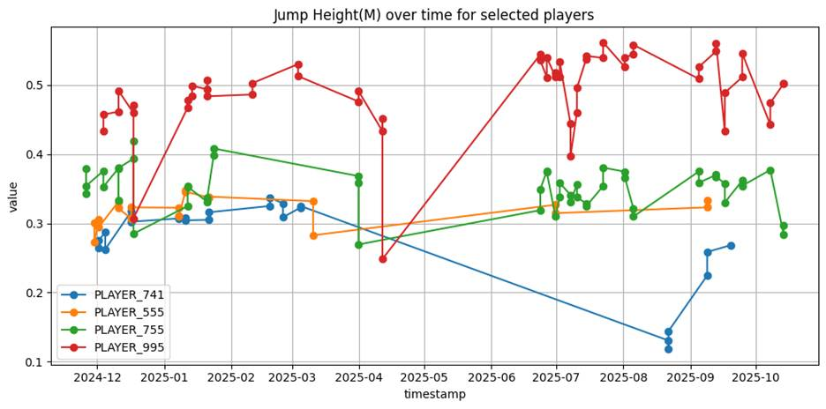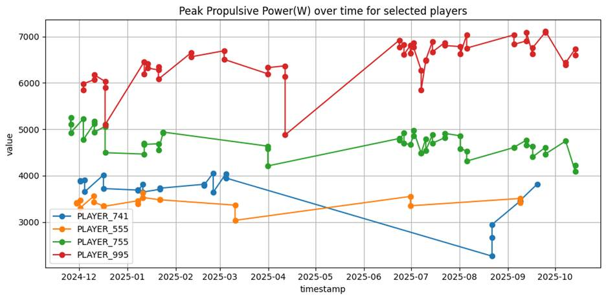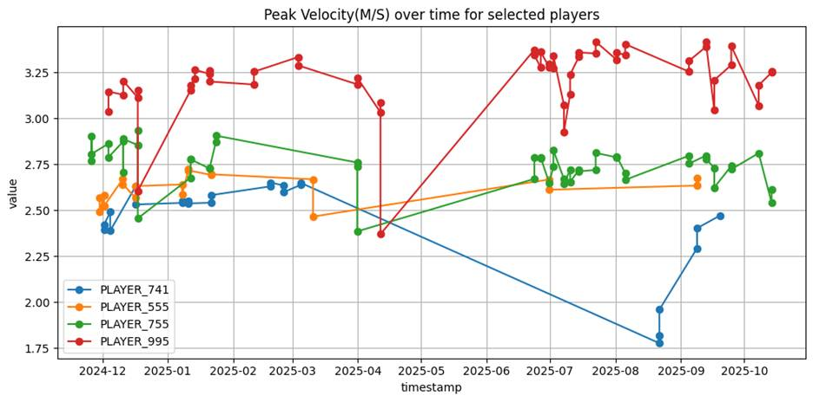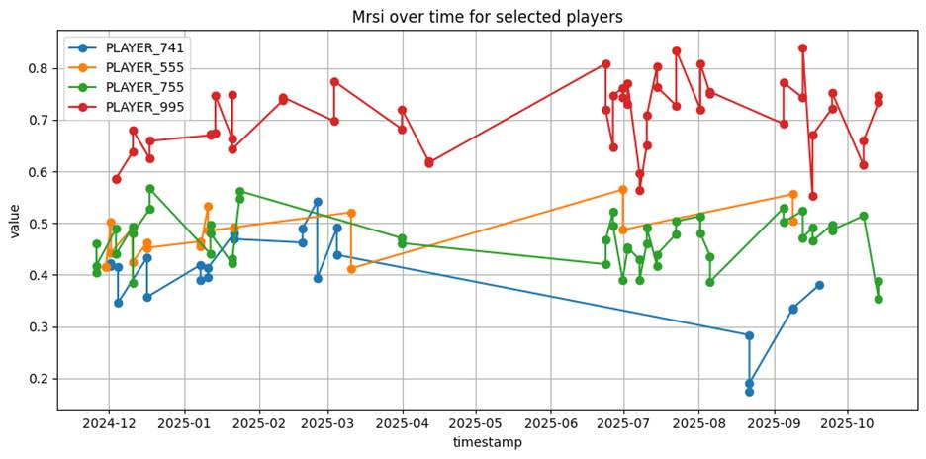

2 players W (1pg)
N
Chart: summary with stats and facts

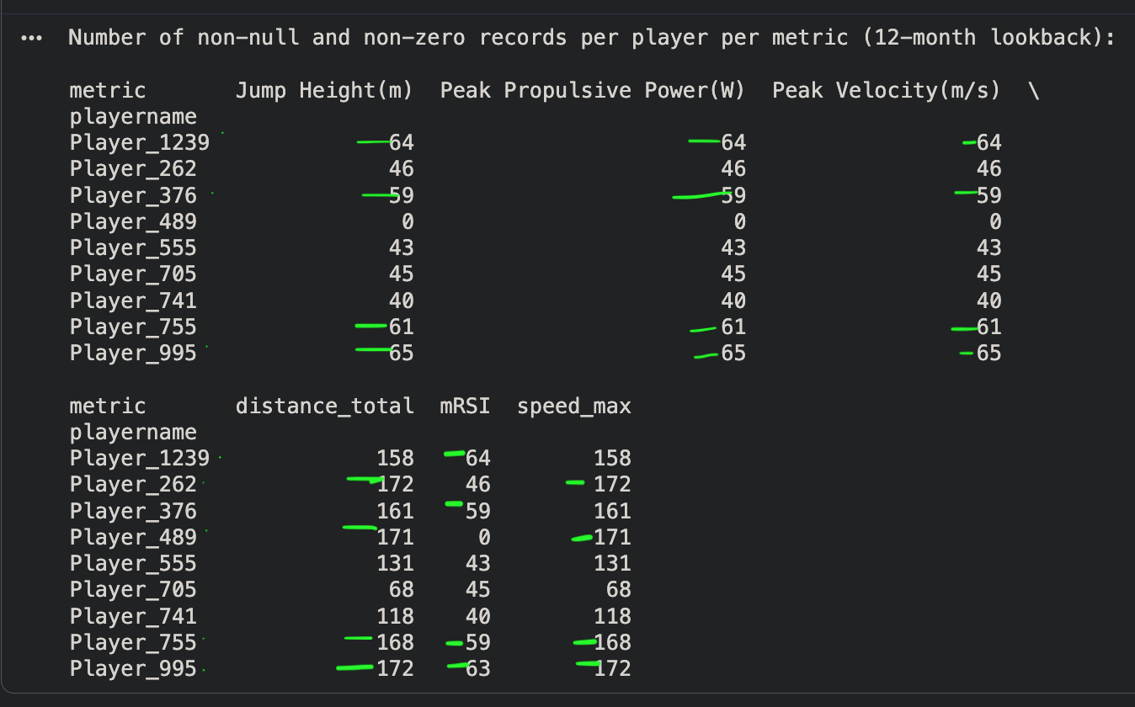 | summary

2 players M (1pg)
J

Metric threshold

S&N

 | low | normal | peak | Team avg | 10% baseline
PPP
Distance total



